Argyll & Bute OWL Group – Report for 2016/17

For the 2016/17 period, Argyll & Bute OWL Group received the following support from OWL Scotland:

- £1000 admin grant – to assist the group with general admin costs including postage, printing, and fuel costs to assist our members who live across the region to attend our meetings

- £500 networking event grant – to help cover the costs of an Argyll networking event including workshop leaders, resources, admin and publicity – this event ran in June 2017 (details below)

- £500 x 5 CPD course grant – to help cover costs of providing CPD/training courses for the 5 satellite groups (Little OWLs) which we have set up across the region (workshop leaders, resources, admin and publicity) - see details below

- Argyll OWL Group also received a special OWL Scotland grant of £5000 to support the development of the five satellite groups (Little OWLs) across Argyll, as well as the Argyll OWL group itself

Development Support Grant
The Argyll & Bute OWL group have successfully delivered a number of projects over the years. However, the geography of Argyll is a challenge to properly facilitate networking and the support of localised activities. With this in mind, the group applied for a special grant from OWL Scotland to enable the group to develop a wider membership, inclusive of new partners.
Given the geography of Argyll the formation of satellite groups was seen as a good way forward to facilitate more local interaction and respond to the differing needs of each area. These satellite groups (little OWLs) will provide practical support for local members and feed back into the main Argyll OWL Group. The Argyll OWL Group will continue to have a strategic role helping to fund activities and development.
The long-term aim is that the little OWL groups become self-sufficient and sustainable. This contract focused on the needs of each group to help them develop rather than impose any one size fits all structure. It is the need for this localised networking and support that will drive their long term sustainability. The Argyll & Bute OWL group will continue to support the little OWL groups through larger themed projects and sharing information and good practice.
Stramash took on this contract on behalf of the group. The contract had three main areas of development:

Development of Little OWLs
Through consultation with members and local publicity, we have set up five satellite groups across the region. Contact lists and email groups have been created for each group to encourage them to communicate effectively. Groups have met on a number of occasions and discussed how they would like to be supported. Each group will benefit from training/CPD using funding from the 2016/17 OWL Scotland CPD grant.

Little OWL Group | To July 2017 | CPD requests | Resource requests
Lorn | 4 meetings in June & Nov 2016 and March & May 2017. Willow workshop during Nov session.  Group members with varying amounts of experience of outdoor learning but all keen to learn and share together. | Willow workshop during Nov 2016.  Future suggestions include:  natural art & craft, flora & fauna ID, foraging, bushcraft, taking the curriculum outdoors, storytelling, planting & growing | Kit for group to use when meeting and for training (eg parachute, tarp, water butt, Kelly kettle, sit-on-tops, string, rope, wooden pegs, first aid kit, mugs)
Mid Argyll | 1 meeting in April 2017 where members shared outdoor learning experiences. Group felt they had less need for CPD and were willing to offer CPD to others – eg health walks for older people | Fire skills training for outdoor cooking | Kelly kettles and tarpaulins
Kintyre | 1 meeting in May 2017. Shared outdoor learning experiences and discussed barriers to getting outdoors | Fire skills training for outdoor cooking | Kelly kettles and tarpaulins  Two outdoor learning books
Cowal | Initial meeting in May 2017. Group members with varying amounts of experience of outdoor learning but all keen to learn and share together. Two ‘sharing skills’ sessions in May & June 2017 as members keen to learn new skills to help them deliver outdoor learning more confidently - using Kelly kettles, cooking damper bread, trying slack lines, knots, tepees and setting up rope pulleys. | Further ‘sharing skills’ sessions - next theme will be practising knots and ideas for activities | TBC
Helensburgh & Lomond | 1 meeting in June 2017. Lots of outdoor learning already happening in area but keen to develop further and encourage others to get involved. Circulated meeting notes to all HTs in Helensburgh & Lomond area, informing them of group | Two twilights for autumn 2017 exploring outdoor learning in general – one to focus on taking numeracy outdoors, one to focus on literacy | Tarps

The development and support of the satellite groups is still very much a work in progress as they continue to build and establish themselves. The Argyll OWL group is seeking further funding to support this through a Seedcorn grant.

Development support for Argyll & Bute OWL group
The grant has enabled those involved in the delivery of this contract to participate in the Argyll OWL group meetings, and carry out tasks such as the organisation of our annual networking event in June 2017. Funding from this grant has also allowed the group to run a photo competition to raise the profile of outdoor learning across the region. The competition had three age categories (9 and under, 10 to 16 and over 16s). Winners from each category received prizes such as rucksacks, outdoor learning books and OWL Scotland mugs. The winning photos are being used to create a calendar which will be circulated to all schools, early years settings and partner organisations across Argyll.
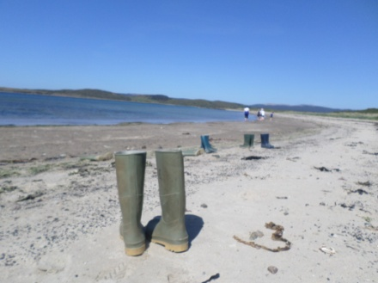
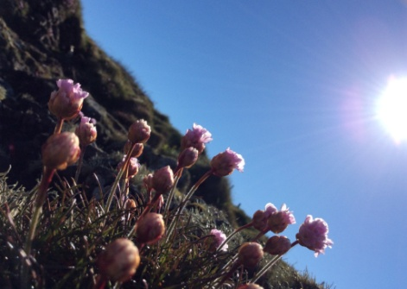
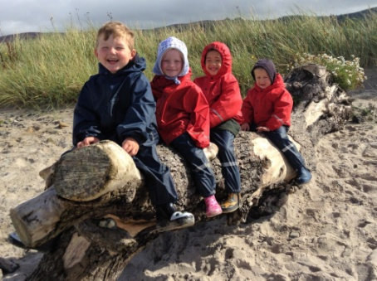
Admin support for Argyll & Bute OWL Group
A significant amount of time has been spent on organising the group’s resources into shared files which the core Argyll & Bute group members can now easily access. Contact lists have been updated, and email accounts created for the Argyll group and the Little OWL groups, which are used to communicate with members. Regular updates have been added to the OWL Scotland webpage and the Argyll group now have their own Facebook page which they use to share good practice, ideas and training & events from across Argyll & beyond.

This grant has achieved the stated outcomes of:
- Setting up satellite groups to improve local support and increase Outdoor & Woodland Learning Activity
- Increasing membership / participants in the group
- More partners will be identified and engaged

CPD course grant
As well as allowing us to provide our Little OWL groups with training to support their needs, the Argyll group have used some of the CPD grant to run an outdoor first aid training course. This course took place in Feb 2016 for 11 participants from across Argyll.

Networking event grant
Around 30 participants took part on a ‘Growing our Own’ networking event in June 2017 in Inveraray. The event provided the opportunity for participants to share their practice, be inspired by new ideas & resources and get outdoors and have some fun. The feedback was very positive and the participants commented on how much they enjoyed the day and felt enthused to continue their outdoor learning journeys. Five workshops were on offer:

Workshop 1 – Wee Green Fingers: Biodiversity Gardening - Early Years & Lower Primary
This workshop explored gardening for biodiversity for young children and look at the Wee Green Fingers resource pack. Practical activities and ideas for exploring biodiversity through gardening and growing for health & wellbeing.
Penny Martin
Workshop 2 – The sea, the shore...and more – All stages
This workshop provided a collection of sea tales from around the world to introduce myths and fantastic beasts, many entwined with the seaweed we find on our own shores. Strange facts and historical events about seaweed will inspire ideas for art, history and geography, as well as science. And of course a game or two to play on the beach.
Patsy Dyer
Workshop 3 – The World Beneath Our Feet: using soil as a learning resource - All stages
The workshop explored the nature of soil and its value to forestry. It covered what makes soil, what does it do, soil PH, pitfall traps and of course, worm charming! Lots of practical activity ideas with the opportunity for discussion, sharing and reviewing.
Sally York, Forestry Commission Scotland
Workshop 4 - Outdoor Learning: making connections within Learning for Sustainability
Primary & Secondary
This workshop explored the connections between the key elements of Learning for Sustainability (LfS) and how they can be successfully integrated within the teaching and learning experience. It explored outdoor learning opportunities, with strong Global Citizenship and Sustainable Development links. Diana Ellis & Kim McCauley, WOSDEC Global Learning Centre
Workshop 5 – Sowing & Growing for Success - All stages
Sowing and planting the RHS way for successful growing. The worksho gave participants the opportunity to learn how to sow seeds, prick out and pot up. Practical growing skills for all that can be transferred back to your school or early years setting.
Bonnie Maggio, OWL Scotland
